

SIMATS ENGINEERING

Saveetha Institute of Medical and Technical Sciences
Chennai- 602105

Student Name: SANJAY J Reg. No.:192511331
Course Code: CSA0732 Slot: C
Course Name: COMPUTER NETWORK FOR DATA CENTRES
Course Faculty: Dr.K.Senthil
Project Title: Design and Evaluation of IPv6 Subnetting and Address Planning Techniques to Improve Network Performance
Module Photographs:
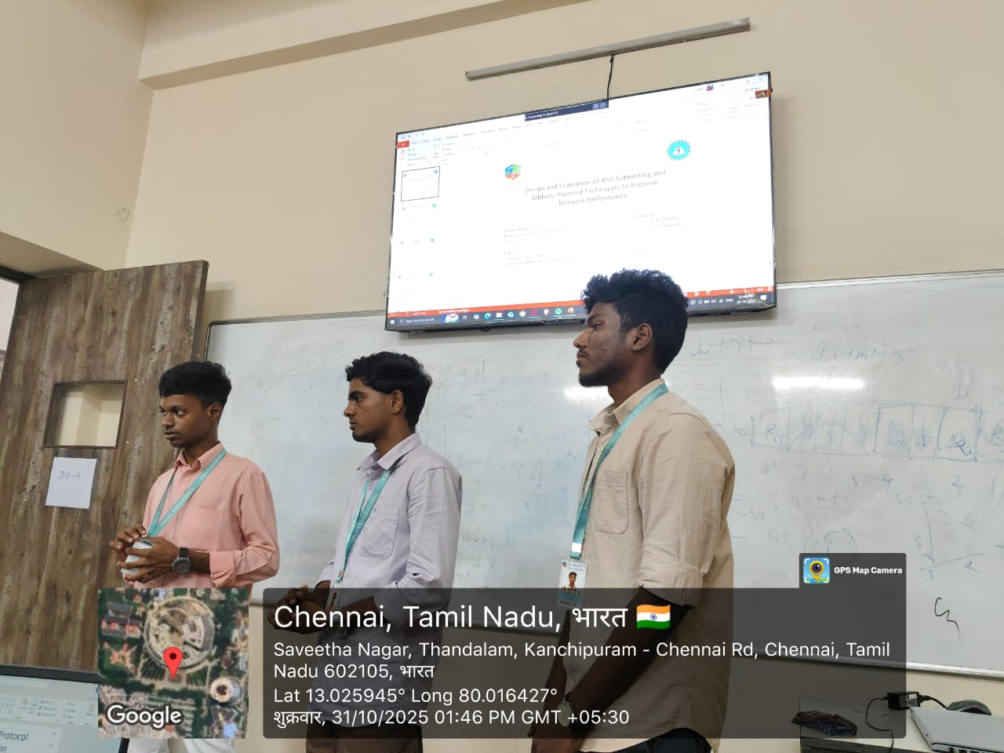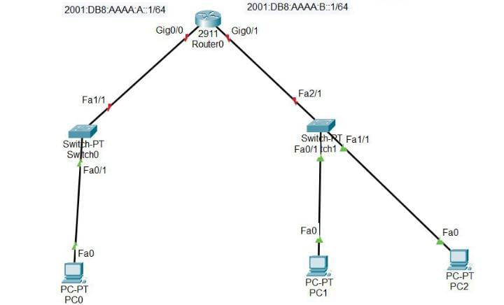
Project Description:
This study focuses on the design and evaluation of IPv6 subnetting and address planning techniques aimed at enhancing overall network performance, scalability, and efficiency. With the vast address space of IPv6, effective subnetting and hierarchical address planning are essential to ensure optimal routing, simplified network management, and improved security. The module “IPv6 Subnetting Tools and Techniques” contributes by exploring practical tools, methodologies, and strategies used for creating efficient IPv6 subnet structures. It emphasizes the use of advanced subnet calculators, automated planning tools, and simulation-based evaluation to analyze the performance impact of different subnetting schemes. Through this, the module provides learners with both theoretical understanding and hands-on experience in designing IPv6 networks that are resilient, future-proof, and performance-optimized.

Student Signature Guide Signature

